|  |  |  |  |
| --- | --- | --- | --- |
| Input | Expected Output | Actual Output | Pass? |
| Initial Checking Balance = $5000  Initial Savings Balance = $10000  Withdraw, Checking $500  Balance, Checking $4500  Withdraw, Savings $200  Balance, Savings $9800  Transfer, Savings to Checking $1000  Final Input:  Balance, Checking  Balance, Savings | “Balance for your checking account: $5500.00”  “Balance for your checking account: $8800.00” | Balance for your checking account: $5500.00  Balance for your checking account: $8800.00 | Yes |
| Initial Checking Balance = $5000  Initial Savings Balance = $10000  Withdraw, Checking $75 (error not an increment of 20)  Withdraw, Checking $80  Withdraw, Savings $500  Deposit, Checking $25  Final Input:  Balance, Checking  Balance, Savings | “Desired amount to be withdrawn must be in increments of $20.”  “Balance for your checking account: $4945.00”  “Balance for your checking account: $9500.00” | Desired amount to be withdrawn must be in increments of $20.”  “Balance for your checking account: $4945.00”  “Balance for your checking account: $9500.00” | Yes |
| Initial Checking Balance = $5000  Initial Savings Balance = $10000  Withdraw, Savings $11000 (error: insufficient funds)  Withdraw, Checking $20  Withdraw, Checking $20  Withdraw, Checking $20  Withdraw, Checking $20  Withdraw, Checking $20 ($1.50 fee)  Final Input  Balance, Checking  Balance, Savings | “There are insufficient funds in this account to complete this transaction”  “You have already made 4 withdrawals from this account. To continue making withdrawals, a service fee of $1.50 will be deducted from the account.”  “Balance for your checking account: $4898.50”  “Balance for your checking account: $10000.00” | “There are insufficient funds in this account to complete this transaction”  “You have already made 4 withdrawals from this account. To continue making withdrawals, a service fee of $1.50 will be deducted from the account.”  “Balance for your checking account: $4898.50”  “Balance for your checking account: $10000.00” | Yes |

Screen Capture of me successfully compiling and executing my Java program:

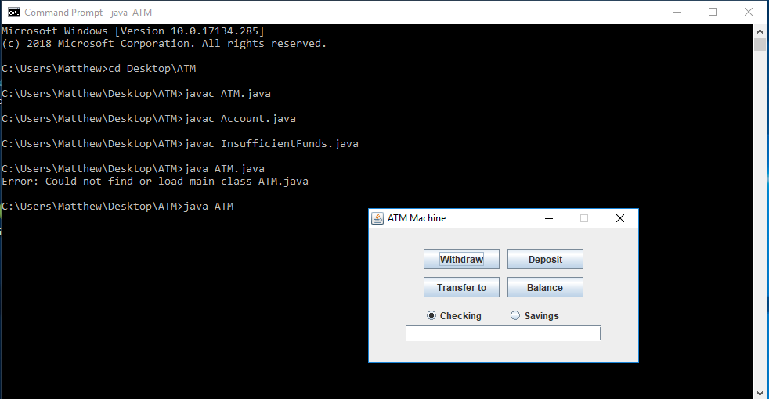

Screen Captures of Final Account Balances for Test Case #1:

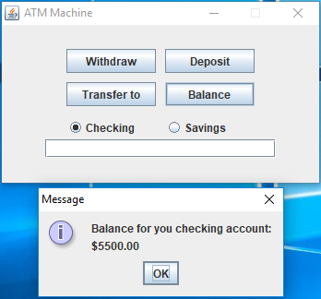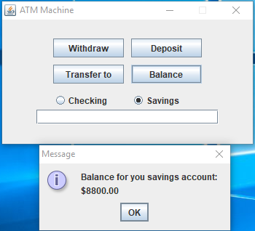

Screen Captures of Non-Increment of 20 Error when Withdrawing and Final Account Balances for Test Case #2:

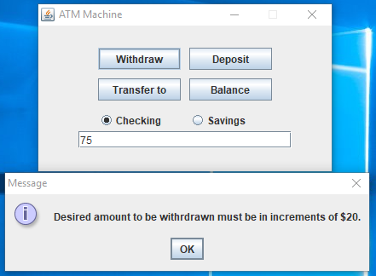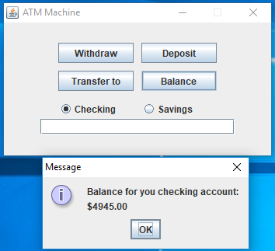

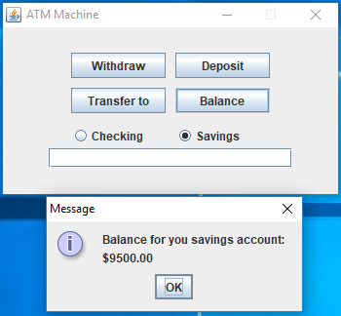

Screen Captures of Insufficient Funds Error, Service Fee Notification, and Final Account Balances for Test Case #3:

